Microscopes
- State the equation to calculate magnification using an image and its actual size.

- Explain why electron microscopes are particularly useful.

_____________________________________________________________________________
_____________________________________________________________________________
_____________________________________________________________________________

- Use the magnification equation to help you complete the missing values in the table. Show all working and units where necessary.

Size of Image | Size of Object | Magnification
10 mm | 0.001 mm
20 mm |  | 5000
 | 5 µm | 10000
15 mm | 0.03 mm
0.5 cm |  | 2500
 | 0.035 mm | 1000

- The image below shows a chloroplast which has a length of 50 µm.
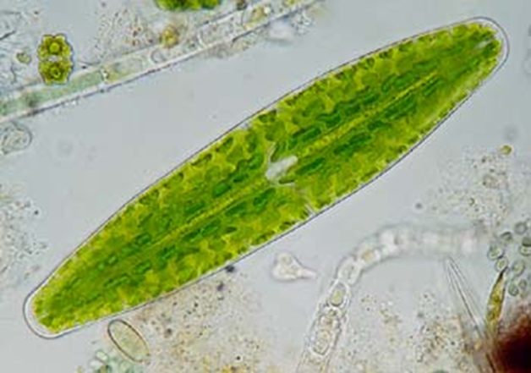

- Is 50 µm the image size or actual object size?

- Use a ruler to measure the length of the bar in the image.

- Use your measurement to calculate the magnification used to produce this image.

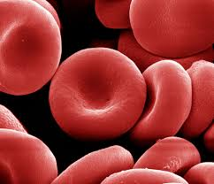
- The image below shows a selection of red blood cells, with the diameter of one marked.

Measure the length of the diameter in the image. This image was obtained at a magnification of 5000.
Use this information to calculate the actual diameter of this red blood cell.

- Ova have an approximate length of 0.1 mm. How big should an image of an ovum appear if it has been magnified 100 times?

